**PROJECT SYNOPSIS**

Clinic Management System

By:

Deepak Mohan

Aman Singh Rajput

Tarun Mishra

**Introduction**

The main objective is to develop the software that covers all the aspects of management and operations of clinics. It enables healthcare providers to improve operational effectiveness, reduce costs, reduce medical errors, reduce time consumption, and enhance delivery of quality of care.

The Clinic Management System will help the clinic to keep and managed

the personal records of the patient. It is designed to help the employee in recording the patient’s record and will change the manual record into computerized records.

This system will also ensure the preservation of personal records and ensure

the accessibility only by the authorized personnel.

**Title of Project**

Clinic Management System

**The Existing System**

In the existing system every appointment and product are maintain manually using registers. This is a time-consuming process and there are high possibilities of inconsistencies and error occurring.

Modifying the records is not very easy, since for a minute change the

whole record would be required to re-entered.

For instance, if the address of any customer changes then locating that customer and doing modification in registers is very tedious task.

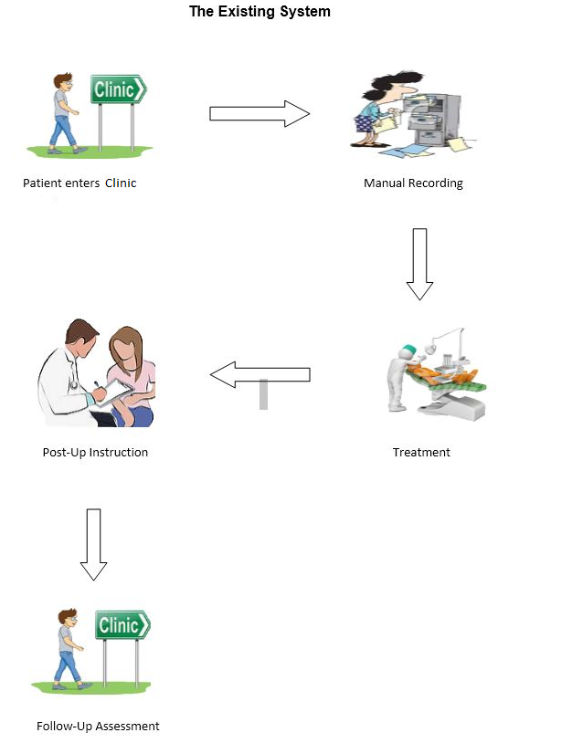

**Limitations of the existing system**

1. To make updating and alter the product-payment status. Lack of proper data retrieval facilities many a times makes work more confusing" which in turn leads to wrong updating.
2. It is difficult to manage multiple forms are vulnerable to illegal access if proper security is not enforced.
3. A lot of human effort or labor us wasted in maintaining the records.
4. It is very difficult and time consuming to maintain all the details into the registers when the organi0ation is very big.
5. It also takes much time for doing entry and checking of records.
6. There is also possibility of mismatching of entries during entry of records.

**Current Problems**

* Storing and retrieving patient information from the logbook is a very time taking and tedious task.
* A lot of manpower is required in record keeping.
* The logbook data is prone to errors.

**The Proposed System**

To overcome the drawbacks of present system and ease the working of such consultancies our project comes into the picture. Our software is multifunctional which includes many details.

The online System maintains systematic records of the supplier" appointments" employees" customers in a cost-effective manner.

All records can be accessed exclusively by the administrator. The administrator has the rights to modify any record.

The proposed system is more user friendly, easy to use reliable and secure. It ensures the safety of data.

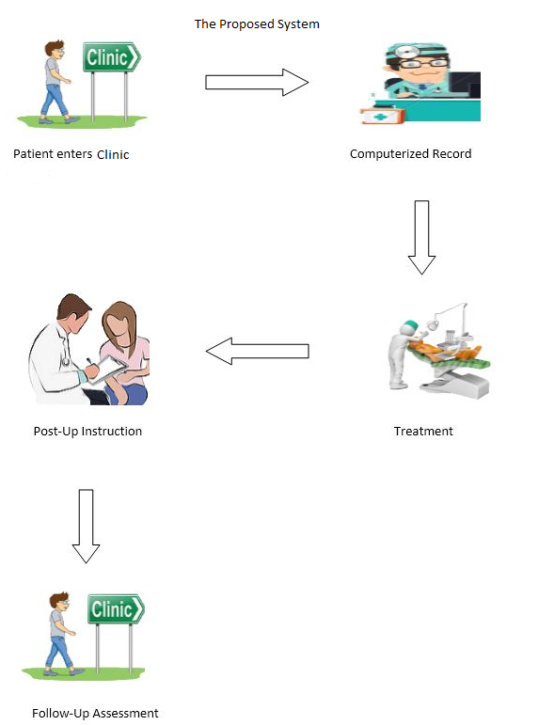

**Advantages of the Proposed System over Existing System**

1. Reduction of paperwork.
2. Human effort or Manual Labor can be reduced drastically.
3. The major operations that are done manually can be done within a matter of seconds.
4. Very less chance of data loss and data retrieval becomes faster.
5. Less scope human errors and errors can be easily rectified.
6. Generating the invoice easily and quickly.

**Modules**

• **User login:** User has an account in the system from where he can check all patient details.

• **Token generation:** System automatically generates token number for new arrivals.

• **Patient information:** Patient information is stored in database along with their prescription.

• **Bill information:** System generates bill for the patient as requested by the receptionist.

• **Prescription Sending:** Doctor sends prescription to receptionist from where receptionist may provide those medicines to the patient.

• **Patient bill generation:** The system automatically calculates the patient bill by considering the number of days of stay, and bed and resources charges incurred.

**Feasibility Study**

Feasibility study includes consideration of all the possible ways to provide a solution to the given problem. The proposed solution should satisfy all the user requirements and should be flexible enough so that future changes can be easily done based on the future upcoming requirements.

* **Economical Feasibility**

This is a very important aspect to be considered while developing a project. We decided the technology based on minimum possible cost factor.

* + All hardware and software cost has to be borne by the organization.
  + Overall, we have estimated that the benefits the organization is going to receive from the proposed system will surely overcome the initial costs and the later running cost for system.
* **Technical Feasibility**

This included the study of function, performance and constraints that may affect the ability to achieve an acceptable system. For this feasibility study, we studied complete functionality to be provided in the system, as described in the System Requirement Specification (SRS), and checked if everything was possible using different type of frontend and backend platforms.

* **Operational Feasibility**

No doubt the proposed system is fully GUI based that is very user friendly and all inputs to be taken all self-explanatory even to a layman. Besides, a proper training should be conducted to let know the essence of the system to the users so that they feel comfortable with new system.

**Hardware and Software Requirements**

|  |  |
| --- | --- |
| **Software Requirement** | |
| Operating System | Microsoft windows |
| **Software :-** | |
| Front –End Software | Visual Basic 6.0 |
| Back-End Software | Microsoft Access |
| **Hardware Requirement** | |
| Processer : | Intel core i3 1.80GHZ |
| RAM : | 2GB or More |
| Monitor : | LCD monitor |
| Keyboard : | Normal keyboard |
| Mouse : | Compatible mouse |